Intermediate Algebra Lecture 10.1: An Introduction to Radicals (Roots) and Radical Functions

In mathematics, a radical expression is defined as any expression containing a radical (√) symbol. Many people mistakenly call this a 'square root' symbol, and many times it is used to determine the square root of a number. However, it can also be used to describe a cube root, a fourth root or higher.

Review of square roots
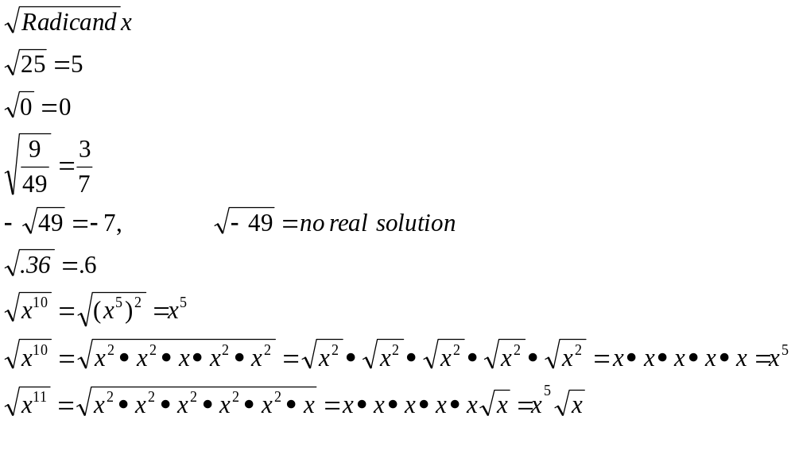
Example
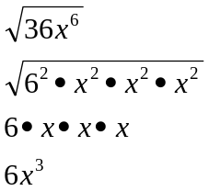

Example
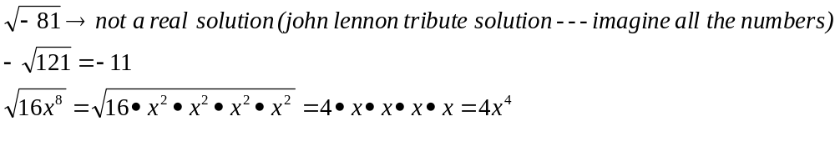
Perfect squares
the product of a rational number multiplied by itself.

Irrational number
an irrational number is a real number that cannot be expressed as a ratio of integers, i.e. as a fraction. Therefore, irrational numbers, when written as decimal numbers, do not terminate, nor do they repeat.

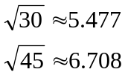

Cube roots
The 3 in the below example represents the degree of the root.
Example
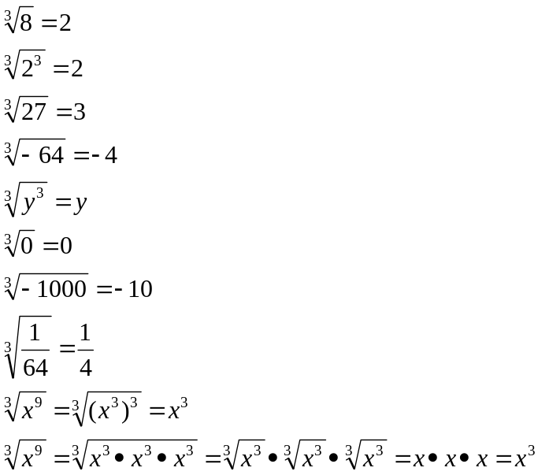

Example
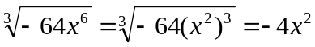

Example
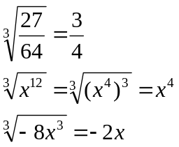

Any root or nth root
* If the degree of the root “n” is an even number then
the radicand cannot be a negative number and be a real solution.

* If the degree of the root “n” is an oddnumber then
the radicand can be a negative number and be a real solution.

Example
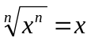

Example
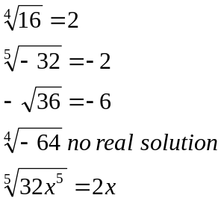

Roots of the form
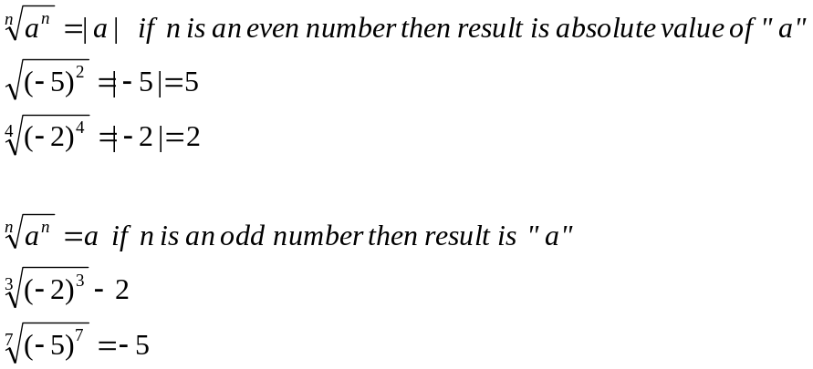

Example
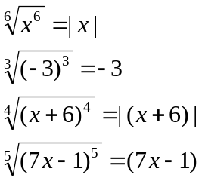

Graphing Radicals

Example
